**Bungee Coding Round**

**Problem Statement:-**

You are provided with a file "main.csv" in the input folder for each question. You need to upload the solution code file and the solution output csv file to respective answer folder in the output folder

1. g. if you are answering question-1 and consider input file as /input/question-1/main.csv and upload the file output csv file to /output/answer-1/main.csv and solution code file also to the same folder

if you are answering question-3 and consider input file as /input/question-3/main.csv and upload the file output csv file to /output/answer-3/main.csv and solution code file also to the same folder

Question-1. Consider input file as /input/question-1/main.csv and give the output to /output/answer-1/main.csv and upload solution code file also to the same folder. Group the year by decades and sum the values

#### Pay attention to the Population column number, summing this column is a mistake

**Expected output:-**

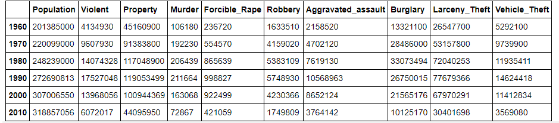

Question-2. Consider input file as /input/question-2/main.csv and give the output to /output/answer-2/main.csv and upload solution code file also to the same folder. For each occupation, calculate the minimum and maximum ages

**Expected output:-**

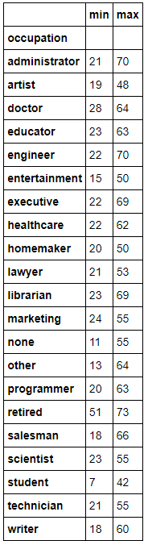

import pandas as pd

employees = pd.read_csv("sample_data/main.csv")

print(employees)

output = employees[['occupation','age']].groupby('occupation').agg(Min=('age', 'min'), max=('age', 'max'))

output.to_csv(r'output.csv', index = True, header = True)

outputs = pd.read_csv("output.csv")

outputs

Question-3. Consider input file as /input/question-3/main.csv and give the output to /output/answer-3/main.csv and upload solution code file also to the same folder. Sort the teams by Red Cards, then to Yellow Cards

**Expected output:-**

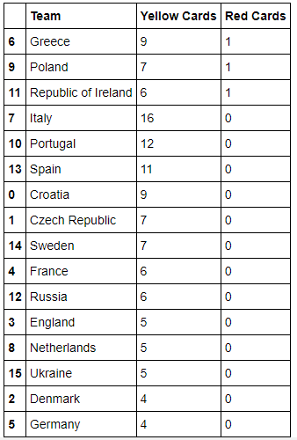

Question 4:- How would you rate the difficult of the assessment on a scale of 1 to 10, 1 being very simple and 10 being very hard?

Do you want another assessment which more focused on Data structures and algorithms?

Please answer this question in the email itself which you are going to send to submit the link of the assessment github repo.

**Submission guidelines:-**

1. You are free to use any coding language.(Don’t use sql or excel to solve the problem or you will be instantly disqualified )
2. Mention the details that are required to run the code in Github readme file.
3. Fork this repo or create a new Github repo that must contain the following:-
   1. Source code of the solution.
   2. Required output files.
4. Github repo should be public.
5. Link to the Github repo is to be submitted as the answer and mailed to [mayank.chandel@bungeetech.com](mailto:mayank.chandel@bungeetech.com)
6. If there are commits made to the github repo after the time of submission then you will be straight away disqualified.